Enhancement of electron field emission by carbon coating on vertically aligned Si nanowires

N.S. Das¹⁾ D. Banerjee¹⁾ and K. K. Chattopadhyay^{1,2)}*
¹⁾School of Materials Science & Nanotechnology, Jadavpur University, Kolkata 700032, India
²⁾Thin Film and NanoScience Laboratory,
Department of Physics, Jadavpur University, Kolkata 700032, India

Abstract
Electron field emission properties of vertically aligned Si nanowires, synthesized by chemically etching p-type Si wafers with different etching times were investigated in detail. Fabrication of Si nanowires was confirmed by field emission scanning electron microscopic investigation. The actual dimensions of the nanowires were confirmed by transmission electron microscopic studies. The a-C thin film was deposited using plasma enhanced chemical vapor deposition (PECVD) method using acetylene as a carbon source. The working voltage was 1.5 kV and the current density was kept at 12.5 mA cm⁻². The electrode distance was maintained at 2.5 cm and the working pressure of acetylene was 0.4 mbar. The presence of carbon was confirmed by Fourier transformed infrared spectroscopy. Finally electron field emissions from all the samples were investigated. It was observed that a thin layer of amorphous carbon coating over the grown Si nanowires enhanced the field emission properties significantly. It was explained as due to deposition of a very thin layer of carbon, the previously smooth surfaces of each individual Si NWs were covered by carbon nanoparticles which effectively increase the roughness of the same. Due to this increment of surface roughness, considerable enhancement of field emission properties was observed and better field enhancement factor was achieved as well.
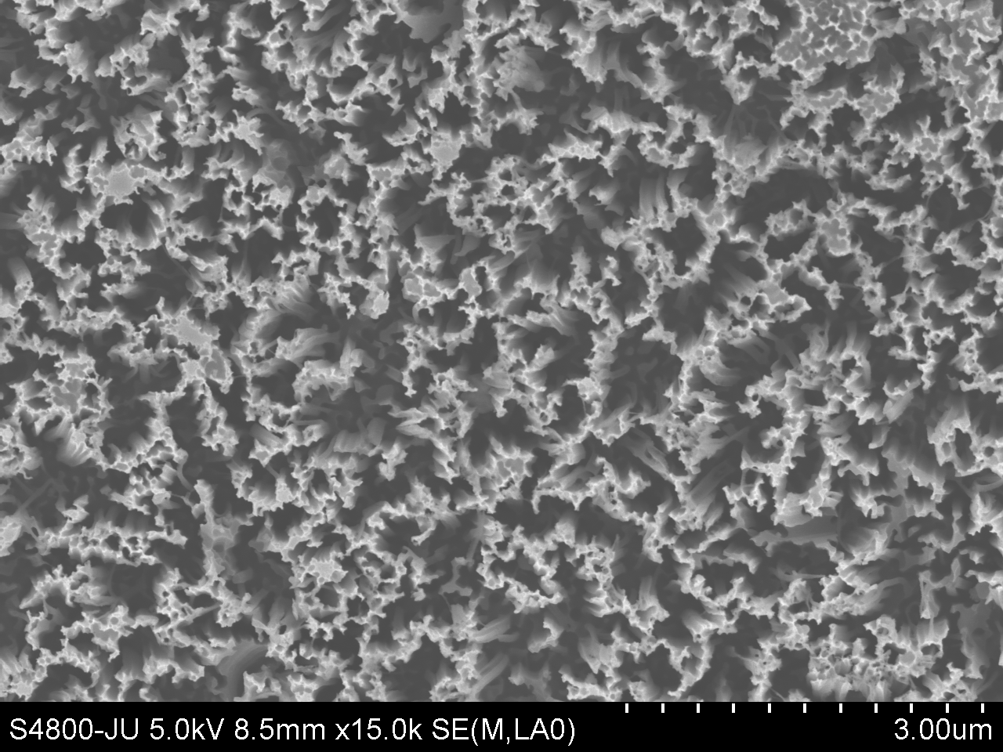

* Corresponding author: Fax: +91 33 2414 6007.
E-mail address: kalyan_chattopadhyay@yahoo.com (K.K. Chattopadhyay)

